* 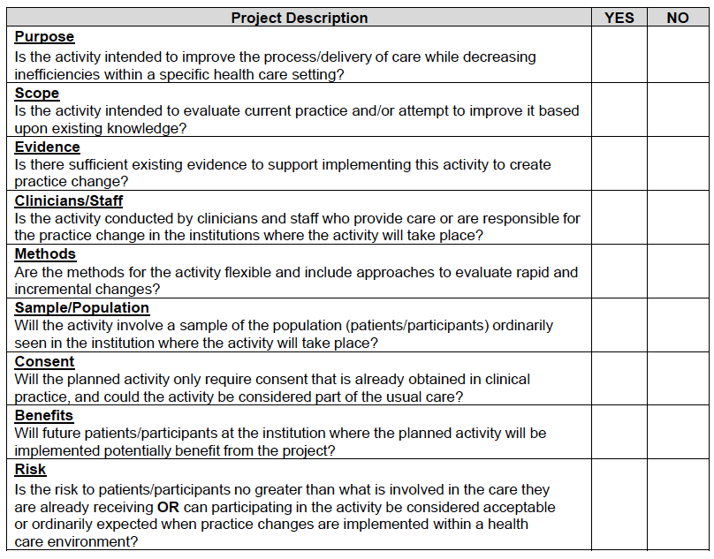Instructions for use: if each of the boxes above are “yes” and NONE of the boxes is “no,” then your project is exempt from IRB review, according to the guidelines for the ethical conduct of human subjects research, as defined by the US Department of Health and Human Services ([45 CFR part 46](http://www.hhs.gov/ohrp/humansubjects/guidance/45cfr46.html) HHS Regulations for the Protection of Human Subjects)
* For more information see: <https://humansubjects.nih.gov/ethical-guidelines-regulations>